**CONTENTS**

1. **INTRODUCTION**
   1. Overview
   2. Purpose
2. **PROBLEM DEFINITION & DESIGN THINKING**

2.1 Empathy Map

2.2 Ideation & Brainstorming Map

1. **RESULT**
2. **ADVANTAGES & DISADVANTAGES**
3. **APPLICATIONS**
4. **CONCLUSION**
5. **FUTURE SCOPE**
6. **APPENDIX**
   1. Source Code

**INTRODUCTION**

The main objective of the sleep tracking app to help users monitor their sleep patterns and improve the quality of their sleep and users can track their sleep time, quality, and receive personalized recommendations to improve their sleep habits.

* 1. **Overview:**
* Sign In/Sign Up Page: Allows users to sign in or sign up for the app to maintain their privacy.
* Sleep Timer: Users can manually start and stop the sleep timer before and after they go to sleep.
* Track Sleep Button: Users can press this button to view the results of their sleep tracking.
* Sleep Results: This app shows the user how long they slept and other details like sleep quality, number of times they woke up, etc.
  1. **Purpose:**
* Monitor Sleep Patterns: This app helps users keep track of their sleep patterns and how long they sleep each night.
* Identify Sleep Problems: By analyzing the sleep data collected by this app, users can identify patterns and potential sleep problems.
* Improve Sleep Quality: With the help of this app, users can develop a better understanding of what factors might be impacting their sleep quality and take steps to improve it.
* Establish Health Goals: Users can set goals for themselves related to their sleep patterns and track their progress towards achieving those goals.

**PROBLEM DEFINITION & DESIGN THINKING**

* 1. **Empathy Map:**

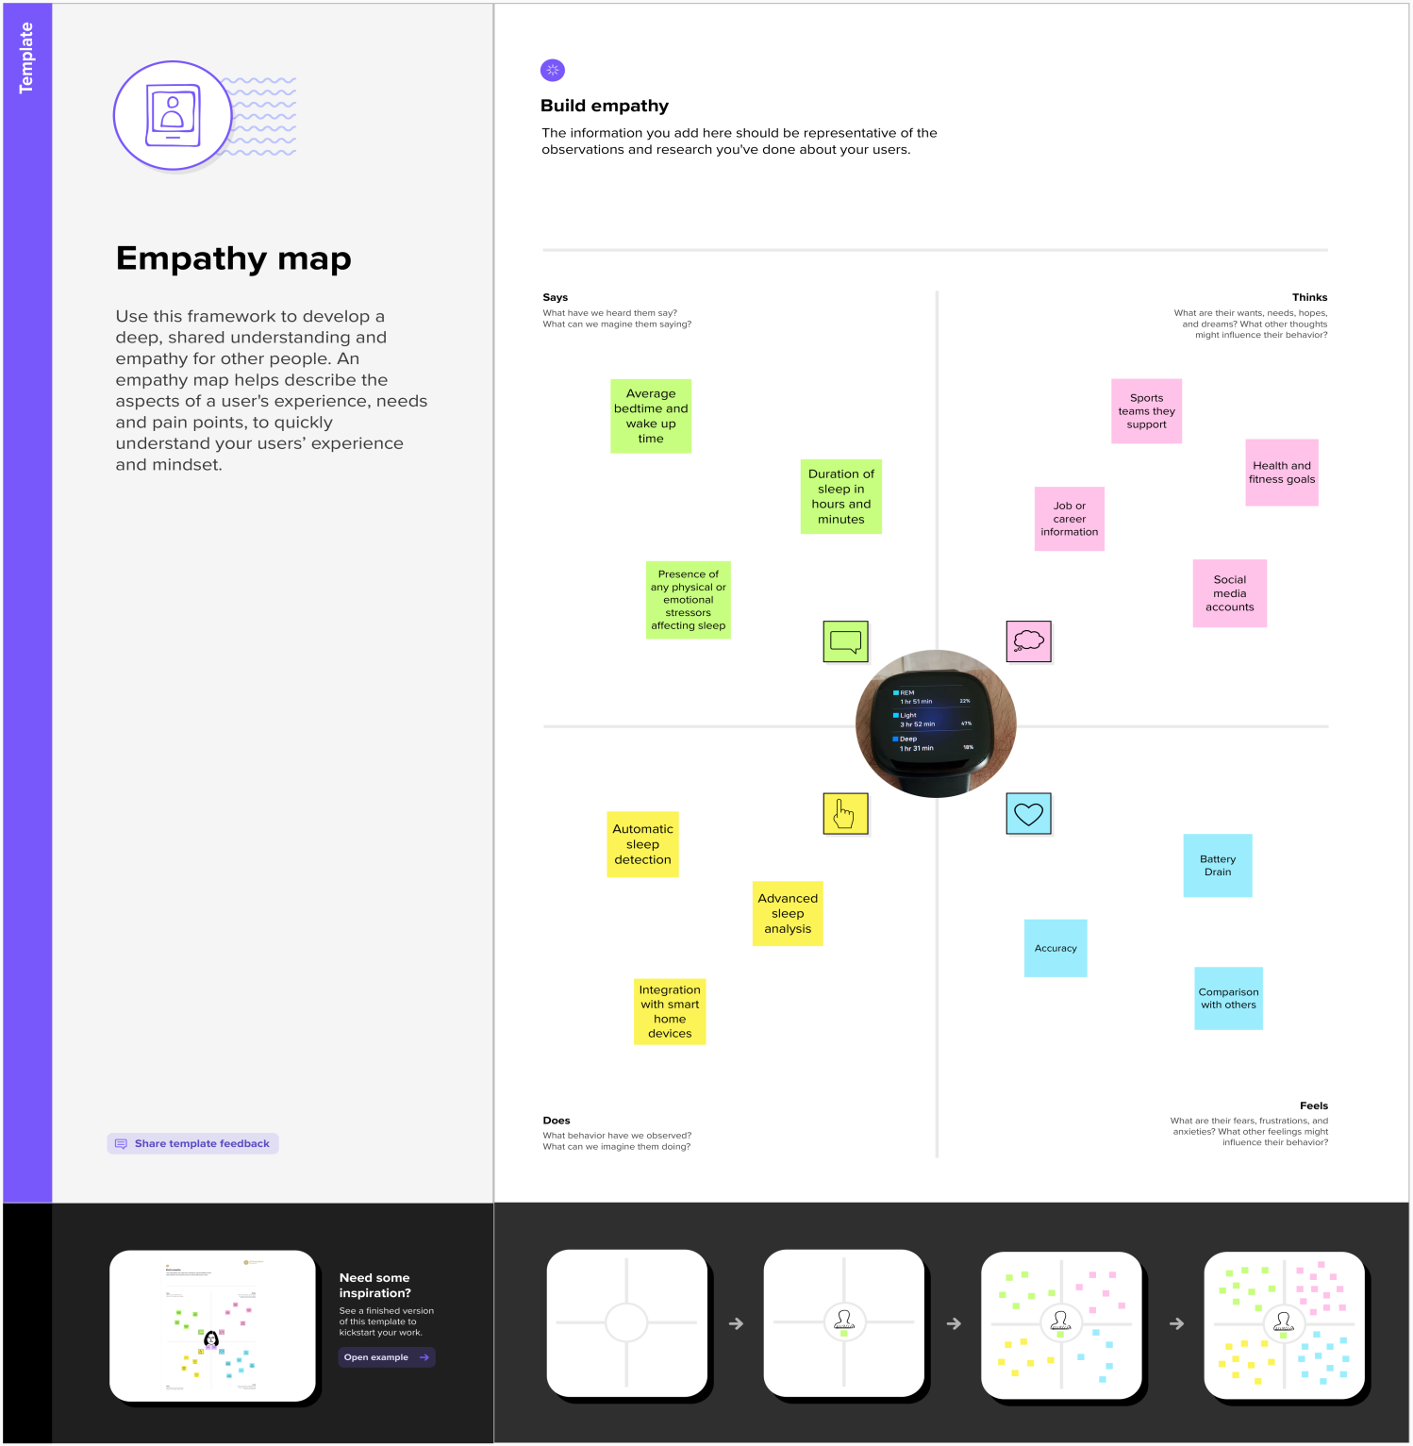

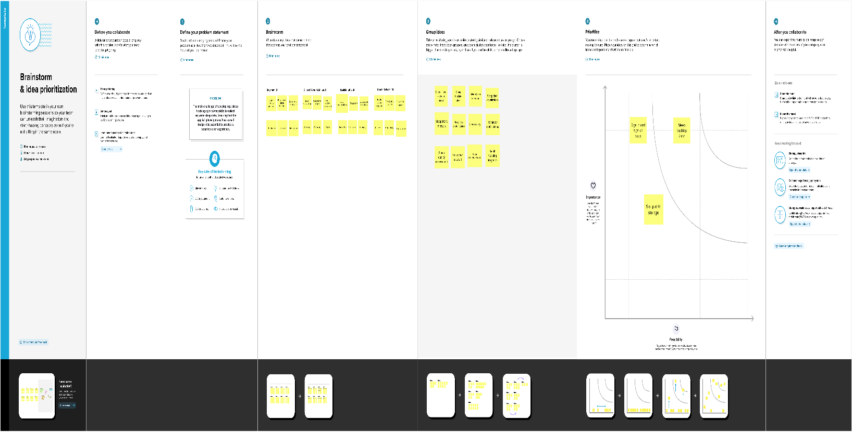**2.2 Ideation & Brainstorming Map:**

**RESULT**

**Sign in Page:**

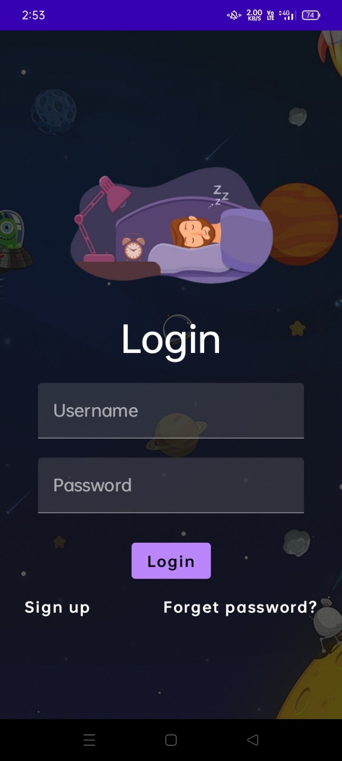

**Sign up Page:**

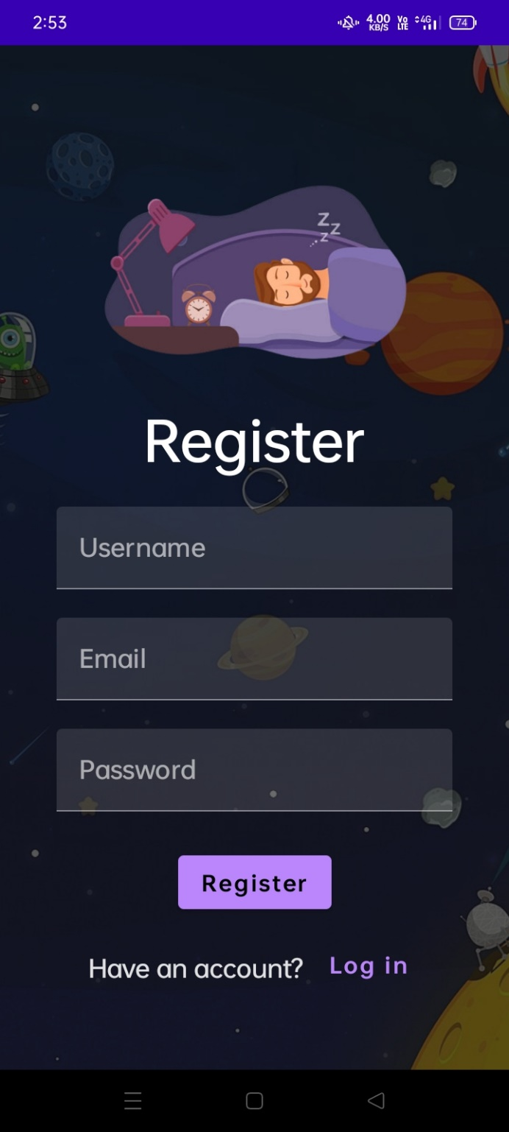

**Home page:**

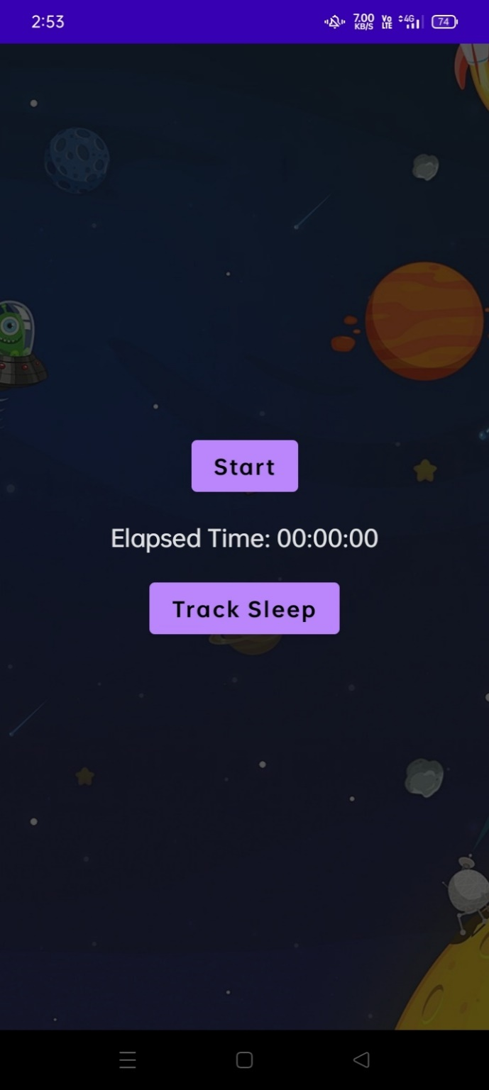

**Timer Start Page:**

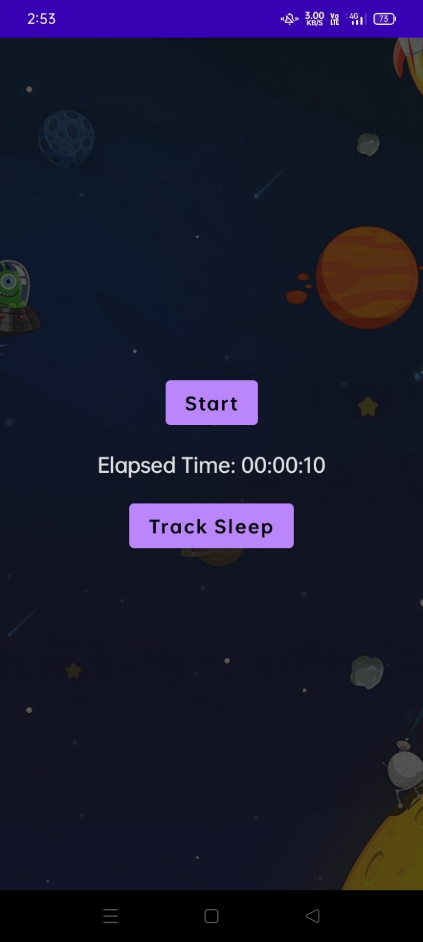

**Timer Stop Page:**

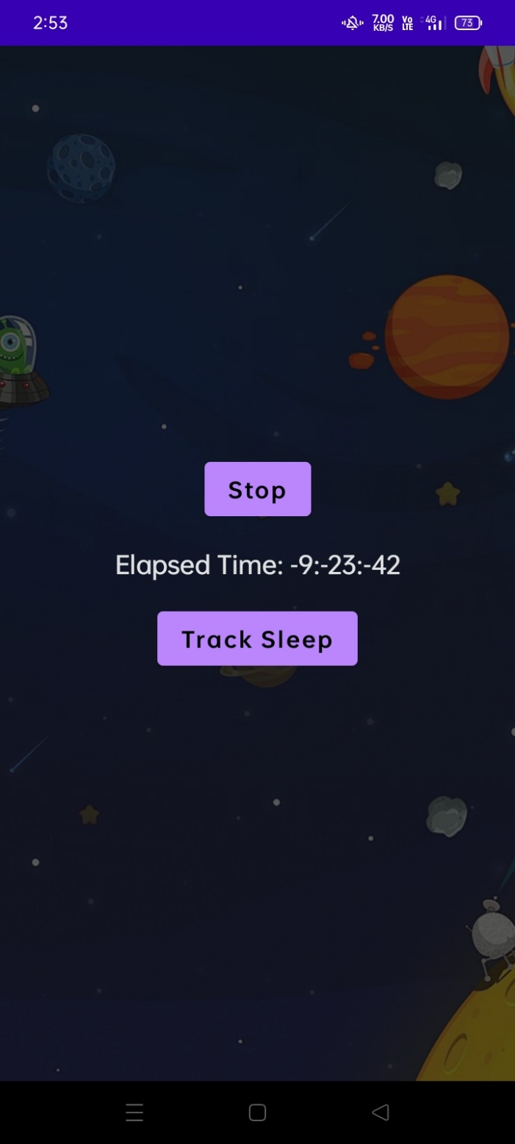

**Result Page:**

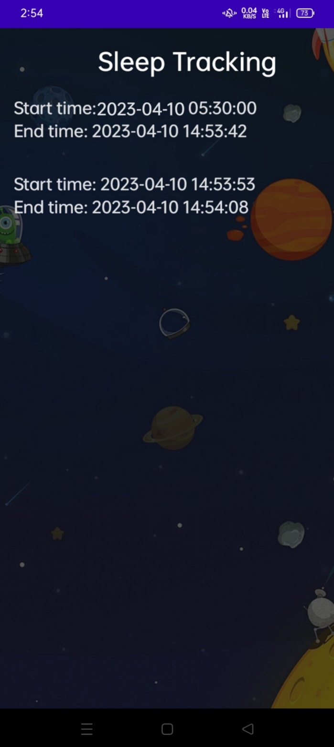

**ADVANTAGES & DISADVANTAGES**

**Advantages:**

* Improved sleep quality: By tracking sleep patterns and providing users with feedback on their sleep quality.
* User privacy: With a sign-in and sign-up page, this app ensures that only authorized users can access their sleep data.
* Customizable: This app allows users to manually start and stop the sleep timer, giving them greater control over the sleep tracking process.
* Convenience: Users can access their sleep data from their smartphone, making it easy to monitor their sleep patterns and progress over time.

**Disadvantages:**

* Inaccurate tracking: Depending on the user's movements during sleep, manually starting and stopping the sleep timer may not always accurately reflect the user's total sleep time, leading to inaccurate data.
* Lack of additional features: It may lack additional features that some users may find helpful, such as sleep analysis tools
* Limited compatibility: This app may not be compatible with all Android devices, limiting its accessibility to a certain group of users.

**APPLICATIONS**

* Create a Sign Up and Sign In page: Users should be able to sign up with their email and password, and then log in to access the app's main features.
* Create a home page: Once the user logs in, they should be taken to a home page that includes a button to manually start and stop the sleep tracking timer.
* Create a timer: This app should include a timer that starts counting once the user taps the "Start Sleep Tracking" button, and stops when the user taps the "Stop Sleep Tracking" button.
* Track the data: When the user taps the "Track Sleep" button, the app should save the start and end time of the sleep tracking session, as well as any additional data you want to track (e.g., sleep quality, duration, interruptions, etc.).
* View results: Finally, this app should display the tracked data in an easy-to-read format (e.g., a chart or graph) so that the user can analyze their sleep patterns over time.

**Conclusion**

We conclude that the sleep tracking app for Android provides users with a convenient and user-friendly way to monitor their sleep patterns. With the app's sign in and signup page, users can be assured of their privacy and security. The app also features a manual timer that allows users to start and stop the tracking before and after sleep. Once the tracking is complete, users can easily view their sleep results by pressing the "Track Sleep" button. With this app, users can gain insight into their sleep quality and make adjustments to improve their overall well-being.

**Future Scopes**

In future adding more sources to provide the sleep tracking app to provide insights on the user's sleep patterns, such as the duration and quality of sleep, and make recommendations for improving sleep quality. Based on the user's sleep patterns, the app could provide a smart alarm that wakes the user up at the optimal time in their sleep cycle, when they are in a lighter stage of sleep. This app could use sensors in the user's phone or wearable device to monitor the sleep environment, such as noise levels and temperature, and provide recommendations for improving sleep conditions. This app could integrate with other health apps, such as fitness and nutrition trackers, to provide a comprehensive view of the user's overall health and wellness. It provides personalized coaching and support to users who are struggling with sleep, including tips and strategies for improving sleep hygiene and addressing sleep disorders.

**APPENDIX**

**Source code:**

**https://github.com/BDaya-Ram/Sleep_Tracking**

**Code:**

1. **LoginActivity.kt**

package com.example.projectone  
  
import android.content.Context  
import android.content.Intent  
import android.os.Bundle  
import androidx.activity.ComponentActivity  
import androidx.activity.compose.setContent  
import androidx.compose.foundation.Image  
import androidx.compose.foundation.layout.*  
import androidx.compose.material.*  
import androidx.compose.runtime.*  
import androidx.compose.ui.Alignment  
import androidx.compose.ui.Modifier  
import androidx.compose.ui.draw.alpha  
import androidx.compose.ui.graphics.Color  
import androidx.compose.ui.layout.ContentScale  
import androidx.compose.ui.res.painterResource  
import androidx.compose.ui.text.font.FontFamily  
import androidx.compose.ui.text.font.FontWeight  
import androidx.compose.ui.unit.dp  
import androidx.compose.ui.unit.sp  
import androidx.core.content.ContextCompat  
import com.example.projectone.ui.theme.ProjectOneTheme  
  
  
class LoginActivity : ComponentActivity() {  
 private lateinit var databaseHelper: UserDatabaseHelper  
 override fun onCreate(savedInstanceState: Bundle?) {  
 super.onCreate(savedInstanceState)  
 databaseHelper = UserDatabaseHelper(this)  
 *setContent* **{** *ProjectOneTheme* **{** *// A surface container using the 'background' color from the theme* Surface(  
 modifier = Modifier.*fillMaxSize*(),  
 color = MaterialTheme.colors.background  
 ) **{** *LoginScreen*(this, databaseHelper)  
 **}  
 }  
 }** }  
}  
@Composable  
fun LoginScreen(context: Context, databaseHelper: UserDatabaseHelper) {  
 var username by *remember* **{** *mutableStateOf*("") **}** var password by remember **{** *mutableStateOf*("") **}** var error by *remember* **{** *mutableStateOf*("") **}** val imageModifier = Modifier  
 Image(  
 painterResource(id = R.drawable.*sleeptracking*),  
 contentScale = ContentScale.FillHeight,  
 contentDescription = "",  
 modifier = imageModifier  
 .*alpha*(0.3F),  
 )  
 Column(  
 modifier = Modifier.*fillMaxSize*(),  
 horizontalAlignment = Alignment.CenterHorizontally,  
 verticalArrangement = Arrangement.Center  
 ) **{** Image(  
 painter = painterResource(id = R.drawable.*sleep*),  
 contentDescription = "",  
  
 modifier = imageModifier  
 .*width*(260.*dp*)  
 .*height*(200.*dp*)  
 )  
 *Text*(  
 fontSize = 36.*sp*,  
 fontWeight = FontWeight.ExtraBold,  
 fontFamily = FontFamily.Cursive,  
 color = Color.White,  
 text = "Login"  
 )  
 *Spacer*(modifier = Modifier.*height*(10.*dp*))  
  
 *TextField*(  
 value = username,  
 onValueChange = **{** username = **it }**,  
 label = **{** *Text*("Username") **}**,  
 modifier = Modifier.*padding*(10.*dp*)  
 .*width*(280.*dp*)  
 )  
  
 *TextField*(  
 value = password,  
 onValueChange = **{** password = **it }**,  
 label = **{** Text("Password") **}**,  
 modifier = Modifier.*padding*(10.*dp*)  
 .*width*(280.*dp*)  
 )  
  
 if (error.*isNotEmpty*()) {  
 Text(  
 text = error,  
 color = MaterialTheme.colors.error,  
 modifier = Modifier.*padding*(vertical = 16.*dp*)  
 )  
 }  
  
 Button(  
 onClick = **{** if (username.*isNotEmpty*() && password.*isNotEmpty*()) {  
 val user = databaseHelper.getUserByUsername(username)  
 if (user != null && user.password == password) {  
 error = "Successfully log in"  
 context.startActivity(  
 Intent(  
 context,  
 MainActivity::class.*java* )  
 )  
  
 *//onLoginSuccess()* } else {  
 error = "Invalid username or password"  
 }  
 } else {  
 error = "Please fill all fields"  
 }  
 **}**,  
 modifier = Modifier.*padding*(top = 16.*dp*)  
 ) **{** *Text*(text = "Login")  
 **}** *Row* **{** *TextButton*(onClick = **{**context.startActivity(  
 Intent(  
 context,  
 MainActivity2::class.*java* )  
 )**}** )  
 **{** Text(color = Color.White,text = "Sign up") **}** TextButton(onClick = **{** */*startActivity(  
 Intent(  
 applicationContext,  
 MainActivity2::class.java  
 )  
 )*/* **}**)  
  
 **{** Spacer(modifier = Modifier.*width*(60.*dp*))  
 *Text*(color = Color.White,text = "Forget password?")  
 **}  
 }  
 }**}  
private fun startMainPage(context: Context) {  
 val intent = Intent(context, MainActivity2::class.*java*)  
 ContextCompat.startActivity(context, intent, null)  
}

1. **MainActivity.kt**

package com.example.projectone  
  
import android.content.Context  
import android.content.Intent  
import android.icu.text.SimpleDateFormat  
import android.os.Bundle  
import androidx.activity.ComponentActivity  
import androidx.activity.compose.setContent  
import androidx.compose.foundation.Image  
import androidx.compose.foundation.layout.*  
import androidx.compose.material.Button  
import androidx.compose.material.MaterialTheme  
import androidx.compose.material.Surface  
import androidx.compose.material.Text  
import androidx.compose.runtime.*  
import androidx.compose.ui.Alignment  
import androidx.compose.ui.Modifier  
import androidx.compose.ui.draw.alpha  
import androidx.compose.ui.layout.ContentScale  
import androidx.compose.ui.res.painterResource  
import androidx.compose.ui.unit.dp  
import androidx.core.content.ContextCompat  
import com.example.projectone.ui.theme.ProjectOneTheme  
import java.util.*  
  
class MainActivity : ComponentActivity() {  
  
 private lateinit var databaseHelper: TimeLogDatabaseHelper  
  
 override fun onCreate(savedInstanceState: Bundle?) {  
 super.onCreate(savedInstanceState)  
 databaseHelper = TimeLogDatabaseHelper(this)  
 databaseHelper.deleteAllData()  
 *setContent* **{** *ProjectOneTheme* **{** *// A surface container using the 'background' color from the theme* Surface(  
 modifier = Modifier.*fillMaxSize*(),  
 color = MaterialTheme.colors.background  
 ) **{** *MyScreen*(this,databaseHelper)  
 **}  
 }  
 }** }  
}  
@Composable  
fun MyScreen(context: Context, databaseHelper: TimeLogDatabaseHelper) {  
 var startTime by remember **{** *mutableStateOf*(0L) **}** var elapsedTime by *remember* **{** *mutableStateOf*(0L) **}** var isRunning by remember **{** *mutableStateOf*(false) **}** val imageModifier = Modifier  
 Image(  
 *painterResource*(id = R.drawable.*sleeptracking*),  
 contentScale = ContentScale.FillHeight,  
 contentDescription = "",  
 modifier = imageModifier  
 .*alpha*(0.3F),  
 )  
  
 Column(  
 modifier = Modifier.*fillMaxSize*(),  
 horizontalAlignment = Alignment.CenterHorizontally,  
 verticalArrangement = Arrangement.Center  
 ) **{** if (!isRunning) {  
 Button(onClick = **{** startTime = System.currentTimeMillis()  
 isRunning = true  
 **}**) **{** *Text*("Start")  
 *//databaseHelper.addTimeLog(startTime)* **}** } else {  
 *Button*(onClick = **{** elapsedTime = System.currentTimeMillis()  
 isRunning = false  
 **}**) **{** *Text*("Stop")  
 databaseHelper.addTimeLog(elapsedTime,startTime)  
 **}** }  
 *Spacer*(modifier = Modifier.*height*(16.*dp*))  
 Text(text = "Elapsed Time: ${*formatTime*(elapsedTime - startTime)}")  
  
  
 Spacer(modifier = Modifier.*height*(16.*dp*))  
 Button(onClick = **{** context.startActivity(  
 Intent(  
 context,  
 TrackActivity::class.*java* )  
 ) **}**) **{** *Text*(text = "Track Sleep")  
 **}  
  
 }**}  
  
private fun startTrackActivity(context: Context) {  
 val intent = Intent(context, TrackActivity::class.*java*)  
 ContextCompat.startActivity(context, intent, null)  
}  
fun getCurrentDateTime(): String {  
 val dateFormat = SimpleDateFormat("yyyy-MM-dd HH:mm:ss", Locale.getDefault())  
 val currentTime = System.currentTimeMillis()  
 return dateFormat.format(Date(currentTime))  
}  
  
fun formatTime(timeInMillis: Long): String {  
 val hours = (timeInMillis / (1000 * 60 * 60)) % 24  
 val minutes = (timeInMillis / (1000 * 60)) % 60  
 val seconds = (timeInMillis / 1000) % 60  
 return String.*format*("%02d:%02d:%02d", hours, minutes, seconds)  
}

1. **RegisterActivity.kt**

package com.example.projectone  
  
import android.content.Context  
import android.content.Intent  
import android.os.Bundle  
import androidx.activity.ComponentActivity  
import androidx.activity.compose.setContent  
import androidx.compose.foundation.Image  
import androidx.compose.foundation.layout.*  
import androidx.compose.material.*  
import androidx.compose.runtime.*  
import androidx.compose.ui.Alignment  
import androidx.compose.ui.Modifier  
import androidx.compose.ui.draw.alpha  
import androidx.compose.ui.graphics.Color  
import androidx.compose.ui.layout.ContentScale  
import androidx.compose.ui.res.painterResource  
import androidx.compose.ui.text.font.FontFamily  
import androidx.compose.ui.text.font.FontWeight  
import androidx.compose.ui.unit.dp  
import androidx.compose.ui.unit.sp  
import androidx.core.content.ContextCompat  
import com.example.projectone.ui.theme.ProjectOneTheme  
  
  
class MainActivity2 : ComponentActivity() {  
 private lateinit var databaseHelper: UserDatabaseHelper  
 override fun onCreate(savedInstanceState: Bundle?) {  
 super.onCreate(savedInstanceState)  
 databaseHelper = UserDatabaseHelper(this)  
 *setContent* **{** ProjectOneTheme **{** *// A surface container using the 'background' color from the theme* Surface(  
 modifier = Modifier.*fillMaxSize*(),  
 color = MaterialTheme.colors.background  
 ) **{** *RegistrationScreen*(this,databaseHelper)  
 **}  
 }  
 }** }  
}  
  
  
@Composable  
fun RegistrationScreen(context: Context, databaseHelper: UserDatabaseHelper) {  
 var username by *remember* **{** *mutableStateOf*("") **}** var password by remember **{** *mutableStateOf*("") **}** var email by *remember* **{** *mutableStateOf*("") **}** var error by *remember* **{** *mutableStateOf*("") **}** val imageModifier = Modifier  
 Image(  
 painterResource(id = R.drawable.*sleeptracking*),  
 contentScale = ContentScale.FillHeight,  
 contentDescription = "",  
 modifier = imageModifier  
 .*alpha*(0.3F),  
 )  
 *Column*(  
 modifier = Modifier.*fillMaxSize*(),  
 horizontalAlignment = Alignment.CenterHorizontally,  
 verticalArrangement = Arrangement.Center  
 ) **{** *Image*(  
 painter = painterResource(id = R.drawable.*sleep*),  
 contentDescription = "",  
  
 modifier = imageModifier  
 .*width*(260.*dp*)  
 .*height*(200.*dp*)  
 )  
 Text(  
 fontSize = 36.*sp*,  
 fontWeight = FontWeight.ExtraBold,  
 fontFamily = FontFamily.Cursive,  
 color = Color.White,  
 text = "Register"  
 )  
  
 Spacer(modifier = Modifier.*height*(10.*dp*))  
 *TextField*(  
 value = username,  
 onValueChange = **{** username = **it }**,  
 label = **{** *Text*("Username") **}**,  
 modifier = Modifier  
 .*padding*(10.*dp*)  
 .*width*(280.*dp*)  
  
 )  
  
 TextField(  
 value = email,  
 onValueChange = **{** email = **it }**,  
 label = **{** *Text*("Email") **}**,  
 modifier = Modifier  
 .*padding*(10.*dp*)  
 .*width*(280.*dp*)  
 )  
  
 TextField(  
 value = password,  
 onValueChange = **{** password = **it }**,  
 label = **{** *Text*("Password") **}**,  
 modifier = Modifier  
 .*padding*(10.*dp*)  
 .*width*(280.*dp*)  
 )  
  
  
 if (error.*isNotEmpty*()) {  
 Text(  
 text = error,  
 color = MaterialTheme.colors.error,  
 modifier = Modifier.*padding*(vertical = 16.*dp*)  
 )  
 }  
  
 Button(  
 onClick = **{** if (username.*isNotEmpty*() && password.*isNotEmpty*() && email.*isNotEmpty*()) {  
 val user = User(  
 id = null,  
 firstName = username,  
 lastName = null,  
 email = email,  
 password = password  
 )  
 databaseHelper.insertUser(user)  
 error = "User registered successfully"  
 *// Start LoginActivity using the current context* context.startActivity(  
 Intent(  
 context,  
 LoginActivity::class.*java* )  
 )  
  
 } else {  
 error = "Please fill all fields"  
 }  
 **}**,  
 modifier = Modifier.*padding*(top = 16.*dp*)  
 ) **{** *Text*(text = "Register")  
 **}** Spacer(modifier = Modifier.*width*(10.*dp*))  
 Spacer(modifier = Modifier.*height*(10.*dp*))  
  
 Row() **{** *Text*(  
 modifier = Modifier.*padding*(top = 14.*dp*), text = "Have an account?"  
 )  
 TextButton(onClick = **{  
  
 }**)  
  
 **{** Spacer(modifier = Modifier.*width*(10.*dp*))  
 Text(text = "Log in")  
 **}  
 }  
 }**}  
private fun startLoginActivity(context: Context) {  
 val intent = Intent(context, LoginActivity::class.*java*)  
 ContextCompat.startActivity(context, intent, null)  
}

1. **TimeDatabaseHelper.kt**

package com.example.projectone  
  
import android.annotation.SuppressLint  
import android.content.ContentValues  
import android.content.Context  
import android.database.Cursor  
import android.database.sqlite.SQLiteDatabase  
import android.database.sqlite.SQLiteOpenHelper  
import java.util.*  
  
class TimeLogDatabaseHelper(context: Context) : SQLiteOpenHelper(context, DATABASE_NAME, null, DATABASE_VERSION) {  
 companion object {  
 private const val DATABASE_NAME = "timelog.db"  
 private const val DATABASE_VERSION = 1  
 const val TABLE_NAME = "time_logs"  
 private const val COLUMN_ID = "id"  
 const val COLUMN_START_TIME = "start_time"  
 const val COLUMN_END_TIME = "end_time"  
  
 *// Database creation SQL statement* private const val DATABASE_CREATE =  
 "create table $TABLE_NAME ($COLUMN_ID integer primary key autoincrement, " +  
 "$COLUMN_START_TIME integer not null, $COLUMN_END_TIME integer);"  
 }  
  
 override fun onCreate(db: SQLiteDatabase?) {  
 db?.execSQL(DATABASE_CREATE)  
 }  
 override fun onUpgrade(db: SQLiteDatabase?, oldVersion: Int, newVersion: Int) {  
 db?.execSQL("DROP TABLE IF EXISTS $TABLE_NAME")  
 onCreate(db)  
 }  
 *// function to add a new time log to the database* fun addTimeLog(startTime: Long, endTime: Long) {  
 val values = ContentValues()  
 values.put(COLUMN_START_TIME, startTime)  
 values.put(COLUMN_END_TIME, endTime)  
 *writableDatabase*.insert(TABLE_NAME, null, values)  
 }  
 *// function to get all time logs from the database* @SuppressLint("Range")  
 fun getTimeLogs(): List<TimeLog> {  
 val timeLogs = *mutableListOf*<TimeLog>()  
 val cursor = *readableDatabase*.rawQuery("select * from $TABLE_NAME", null)  
 cursor.moveToFirst()  
 while (!cursor.*isAfterLast*) {  
 val id = cursor.getInt(cursor.getColumnIndex(COLUMN_ID))  
 val startTime = cursor.getLong(cursor.getColumnIndex(COLUMN_START_TIME))  
 val endTime = cursor.getLong(cursor.getColumnIndex(COLUMN_END_TIME))  
 timeLogs.add(TimeLog(id, startTime, endTime))  
 cursor.moveToNext()  
 }  
 cursor.close()  
 return timeLogs  
 }  
  
 fun deleteAllData() {  
 *writableDatabase*.execSQL("DELETE FROM $TABLE_NAME")  
 }  
  
 fun getAllData(): Cursor? {  
 val db = this.*writableDatabase* return db.rawQuery("select * from $TABLE_NAME", null)  
 }  
  
 data class TimeLog(val id: Int, val startTime: Long, val endTime: Long?) {  
 fun getFormattedStartTime(): String {  
 return Date(startTime).toString()  
 }  
  
 fun getFormattedEndTime(): String {  
 return endTime?.*let* **{** Date(**it**).toString() **}** ?: "not ended"  
 }  
 }  
}

**5.TrackActivity.kt**

package com.example.projectone  
  
import android.icu.text.SimpleDateFormat  
import android.os.Bundle  
import android.util.Log  
import androidx.activity.ComponentActivity  
import androidx.activity.compose.setContent  
import androidx.compose.foundation.Image  
import androidx.compose.foundation.layout.*  
import androidx.compose.foundation.lazy.LazyColumn  
import androidx.compose.foundation.lazy.LazyRow  
import androidx.compose.foundation.lazy.items  
import androidx.compose.material.MaterialTheme  
import androidx.compose.material.Surface  
import androidx.compose.material.Text  
import androidx.compose.runtime.Composable  
import androidx.compose.ui.Modifier  
import androidx.compose.ui.draw.alpha  
import androidx.compose.ui.graphics.Color  
import androidx.compose.ui.layout.ContentScale  
import androidx.compose.ui.res.painterResource  
import androidx.compose.ui.unit.dp  
import androidx.compose.ui.unit.sp  
import com.example.projectone.ui.theme.ProjectOneTheme  
import java.util.*  
  
class TrackActivity : ComponentActivity() {  
  
 private lateinit var databaseHelper: TimeLogDatabaseHelper  
  
 override fun onCreate(savedInstanceState: Bundle?) {  
 super.onCreate(savedInstanceState)  
  
 databaseHelper = TimeLogDatabaseHelper(this)  
 *setContent* **{** *ProjectOneTheme* **{** *// A surface container using the 'background' color from the theme* Surface(  
 modifier = Modifier.*fillMaxSize*(),  
 color = MaterialTheme.colors.background  
 ) **{** *//ListListScopeSample(timeLogs)* val data=databaseHelper.getTimeLogs();  
 Log.d("Sandeep" ,data.toString())  
 val timeLogs = databaseHelper.getTimeLogs()  
 ListListScopeSample(timeLogs)  
 **}  
 }  
 }** }  
}  
  
  
@Composable  
fun ListListScopeSample(timeLogs: List<TimeLogDatabaseHelper.TimeLog>) {  
 val imageModifier = Modifier  
 Image(  
 painterResource(id = R.drawable.*sleeptracking*),  
 contentScale = ContentScale.FillHeight,  
 contentDescription = "",  
 modifier = imageModifier  
 .*alpha*(0.3F),  
 )  
  
 *Text*(text = "Sleep Tracking", modifier = Modifier.*padding*(top = 16.*dp*, start = 106.*dp* ), color = Color.White, fontSize = 24.*sp*)  
 Spacer(modifier = Modifier.*height*(30.*dp*))  
 LazyRow(  
 modifier = Modifier  
 .*fillMaxSize*()  
 .*padding*(top = 56.*dp*),  
  
 horizontalArrangement = Arrangement.SpaceBetween  
 )**{** item **{** *LazyColumn* **{** *items*(timeLogs) **{** timeLog **->** *Column*(modifier = Modifier.*padding*(16.*dp*)) **{** *//Text("ID: ${timeLog.id}")  
 Text*("Start time: ${*formatDateTime*(timeLog.startTime)}")  
 *Text*("End time: ${timeLog.endTime?.*let* **{** *formatDateTime*(**it**) **}**}")  
 **}  
 }  
 }  
 }  
  
 }** }  
  
private fun formatDateTime(timestamp: Long): String {  
 val dateFormat = SimpleDateFormat("yyyy-MM-dd HH:mm:ss", Locale.getDefault())  
 return dateFormat.format(Date(timestamp))  
}